Mid Engine Monthly Update: What Is Stingray, Z06 and E-Ray New? (John Elegant)
The C8 Stingray continues to get deserved rave reviews from auto media, including from other countries too. https://www.midenginecorvetteforum.com/forum/mid-engine-corvettes/c8-stingray-z06-powertrain-performance-wheels-tires-aa/420096-c8-z06-review-thanks-to-autocar-uk
https://www.midenginecorvetteforum.com/forum/me-discussion-photos-videos/418715-car-driver-reviews-the-70th-anniversary-htc

C8 Stingray owners who want more power, now have a supercharged Lingenfelter-Magnuson 700 HP option. Such a package also produces 675 foot pounds of torque. It is now available for both the coupe and the HTC. Press release and more here: https://www.midenginecorvetteforum.com/forum/mid-engine-corvettes/c8-powertrain-and-performance/415682-lingenfelter-announced-700-hp-supercharger-pricing

The Z06 has started its customer production roll out. It is however at the same slow pace as GM told it would be (first letting us know that in January at Barrett Jackson). So far, depending on when you are reading this, about 40 customer Z06’s have been made. Nicely November we will see greater ramp up production levels. Corvette historians remember that the C8 Stingray’s ramp up was similarly slow, e.g., taking 2 1/2 months to get it to full production levels.. More specifically, it is believed that the 495 Z06 customer allocations already awarded on August 18th would be finished roughly by mid-February, so that when the next batch of Z06 allocations expected on January 19th are awarded and staged for the production line, that the first of the January awarded allocations is just a few cars behind the last of the first-batch-competed 495 of them.
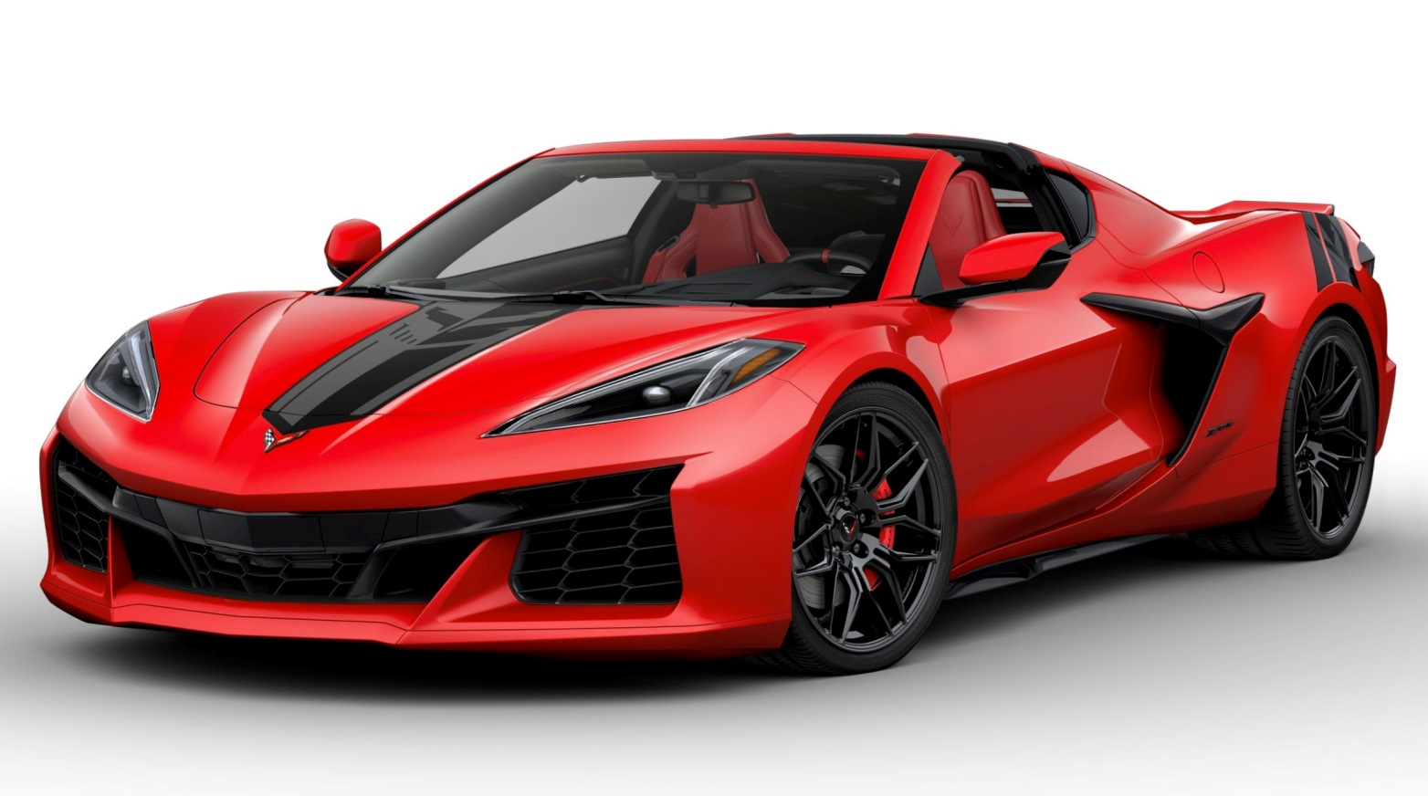
The Z06 Build and Price is out to play on. Rumors are that for those wishing for one in their garage, that just like Ruffles potato chips, you cannot build just one Z06. GUILTY Here’s where to start: https://www.midenginecorvetteforum.com/forum/me-discussion-photos-videos/420436-c8-z06-build-price-works.

The long-awaited independent third party auto media Z06 reviews are in. They are in one place, containing at the link the over 20 media videos of the C8 Z06 based on both street time and track time at the Pittsburg Race track. To say that they are very strongly positive would be an understatement! https://www.midenginecorvetteforum.com/forum/mid-engine-corvettes/c8-stingray-z06-powertrain-performance-wheels-tires-aa/416041-complete-c8-z06-media-reviews-results. Also at the link are reviews by the biggest car magazines. IF you have time for only one review, the most complete, best quality in terms of educational informational content, sound, and video quality is by “savagegeese” here: https://www.midenginecorvetteforum.com/forum/mid-engine-corvettes/mid-engine-exterior-interior-pictures-and-renderings/418764-c8-z06-review-shout-out-for-savagegeese%E2%80%99s-1-video-commentary

The MidEngineCorvetteForum was granted an exclusive interview with Speed Phenom after his testing both the standard and the Z07 version both on country roads around the track and on the track itself. The following thread is about his Z06 driving experiences at the Pitt Track event, containing not just his thoughts and impressions but also three different videos he created as a result: https://www.midenginecorvetteforum.com/forum/me-discussion-photos-videos/417185-interview-with-speed-phenom-re-z06%E2%80%99s-pitt-track

In addition to releasing the Z06 Build and Price program linked above, GM simultaneously put out a bunch of new interior and exterior Z06 pictures. Here are just two of them; remainder of about 20 at the links: https://www.midenginecorvetteforum.com/forum/mid-engine-corvettes/mid-engine-exterior-interior-pictures-and-renderings/421387-latest-gm-z06-exterior-pictures

https://www.midenginecorvetteforum.com/forum/mid-engine-corvettes/mid-engine-exterior-interior-pictures-and-renderings/420629-super-new-gm-interior-z06-pictures

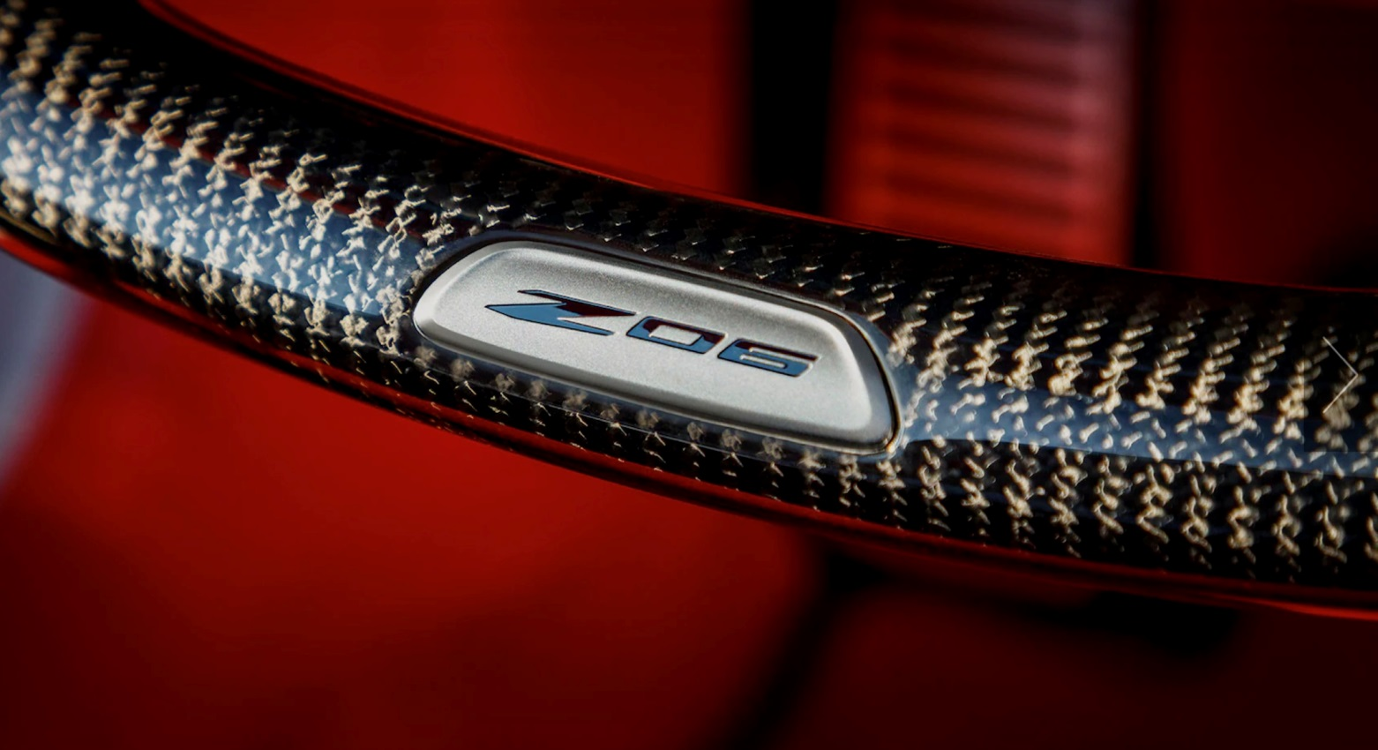

At the time I wrote this (end of October), we had just one major Z06 test specification review article, e.g., by Car and Driver, it called the C8 Z06 the “BEST. CORVETTE. EVER.” With the non-Z07 version, they achieved even with the big wing aero package, 0 to 60 in 2.7 seconds, and the quarter mile with the big wing but without the Cup2 R tires in 10.7 seconds at 129 MPH. More here: https://www.midenginecorvetteforum.com/forum/me-discussion-photos-videos/422296-tested-specs-by-car-and-driver-their-calling-it-%E2%80%9Cbest-corvette-ever%E2%80%9D#post422315

The C8 Z07 was separately tested in 100 degree weather, running the quarter mile at 10.51 @ 130.11 MPH, however for that testing being with that version’s standard its Cup2 R tires. The video and these results are shown in this Emelia Hartford video: https://youtu.be/Reyl1WbF5zQ

Interesting time I had while visiting Rennlist, Porsche’s far biggest forum. While no one would dispute that Porsche’s are greatly engineered sports cars, yet there are quite a few Porsche folks who are turning away from their great sports cars and planning to get a C8 Z06. Here’s a thread I wrote showing re a thread I found on Rennlist; in it, its posters by a very clear margin noted that they were moving to buy a C8 Z06. To be fair and clear, not all said they were selling their Porsche’s, but some were that they were going to buy a Z06 and others commenting about the Z06 being an excellent car they are admiring. Fun; FUN! https://www.midenginecorvetteforum.com/forum/mid-engine-corvettes/c8-stingray-z06-powertrain-performance-wheels-tires-aa/417636-porsche-rennlist-posters-%E2%80%9Cget-a-z06%E2%80%9D

What have we learned about the E-Ray this past month? AutoLine just video reported that the noted inside car industry model analysis company, Auto Forecast Solutions in their internal members-only files stated that the Corvette EV is 1) not coming until the 2026 model year (production starting in May 2025) and that it will not be built at BGA. Were they however referring not to a hybrid C8 with both its LT2 and a hybrid electrification addition, perhaps to an all-electric SUV, or? More to learn starting here: https://www.midenginecorvetteforum.com/forum/general-forums/wheeled-transportation-section/422245-the-ever-changing-corvette-ev-news

Thanks for reading. I hope you are still weekly enjoying your miles of Corvette driving smiles. John

