Mid Engine Monthly Update: Really Good C8 News Unfolding! (John Elegant)

The long requested Bowling Green Assembly Plant public tours are resuming next month. Contact the National Corvette Museum for your tour ticket. Additionally, starting the second quarter of 2023, BGA will initiate the Z06’s LT6 Engine Build Program. The program, limited to owners of new Z06’s whose car is soon to be built, is an exciting next step following the resumption of the public tours. Similar to the past, the Performance Build Center, located within the Bowling Green Assembly Plant, will again allow an upcoming owner of a LT6 to select option “PBC” — to actually build their own motor which will go into their Z06. When completed it will have, though even more prominently, a “Handcrafted By (builder’s name) pride badge” (GM’s name for it) which sits on top of the motor to be seen (of course so much more easily seen in a Z06 coupe). However, instead of earlier BGA Engine Build program in which an owner and a PBBC Engine Assembly Specialist would travel from one to the next progressive work stations, all parts for the motor assembly will be within one “build room.” As previous, one may have a non-participating guest. Pricing has yet to be announced, but many believe it would be increased above its previous $5,000 level to it instead being in the $6,000-$8,000 range. During the entire C7 generation it was offered only 3 years; during that time option “PBC” was chosen by 162 builders (5% of those years).

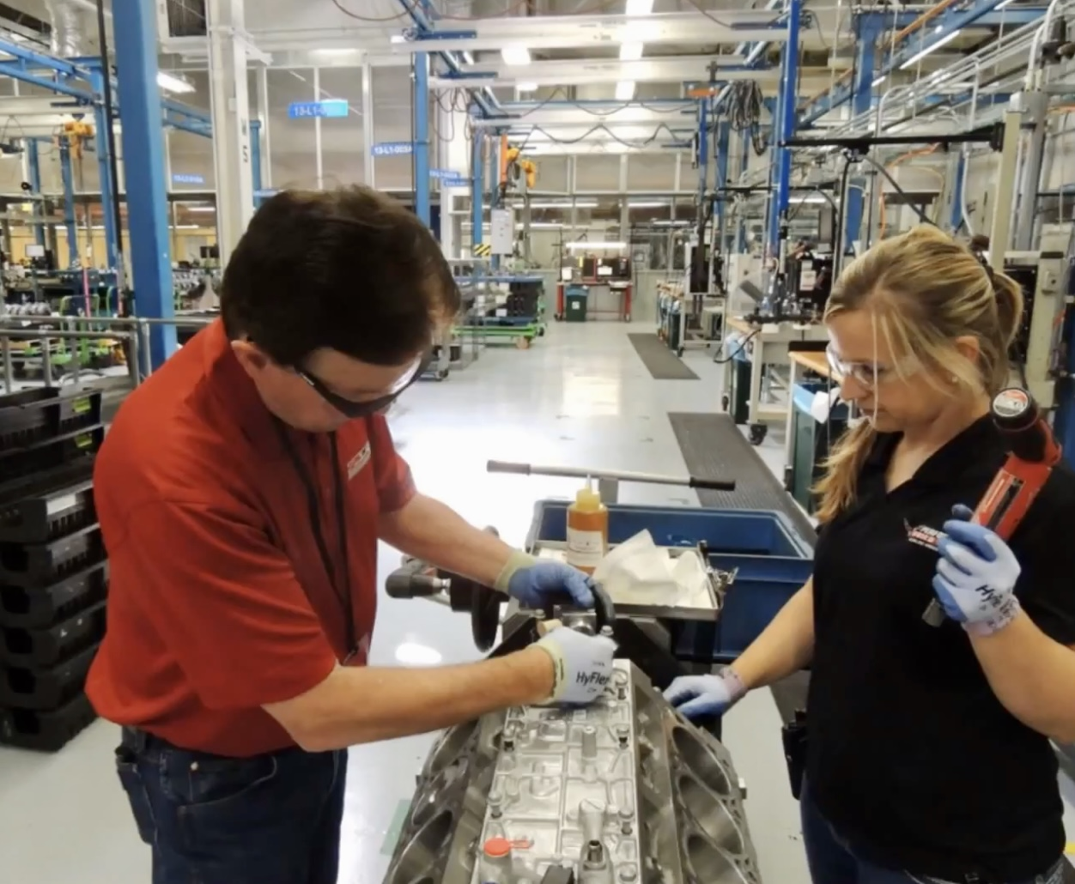
Picture credit to NCM/BGA.
Here’s Kai Spande’s complete BGA Update Seminar at the National Corvette Museum Anniversary event. During its Q&A the question of Buyer’s Tour resumption was also raised, but that timing has not yet been established. Very interesting all the build assembly limitations/conditions imposed on “in what order” different C8’s can go down the line: https://www.midenginecorvetteforum.com/forum/me-discussion-photos-videos/407091-special-kai-spande-seminar-assembly-plant-update

Here’s Harlan’s Charles’ C8 Update Seminar which also took place at the NCM Labor Day Anniversary event: https://www.midenginecorvetteforum.com/forum/mid-engine-corvettes/mid-engine-exterior-interior-pictures-and-renderings/411285-harlan-charles-complete-ncm-presentation

It was a long time, exactly 330 days, between the Z06’s October 26th reveal and the start of regular Z06 production (SORP). Conversely on the bad news side, on September 1st GM announced that all Z06 new allocations would be planned in hibernation until January; however all Z06 orders previously accepted in August are proceeding toward their build. Specifically on Wednesday, September’s 21st the first three customer ordered Z06’s were produced: https://www.midenginecorvetteforum.com/forum/me-discussion-photos-videos/413211-the-first-customer-ordered-2023-corvette-z06s-have-been-built.

GM has four times in public meetings since last January told us that the Z06’s ramp up will be very slow. For example, just like the first week of September 19th, there are only going to be a handful of Z06’s made the following weeks of September 26th, October 3rd and thereafter. Full ramp up of Z06 production might well not occur literally for several months (just as it took several months for the C8 Stingray to reach its daily production.

The first three customer Z06’s made were: Rick Hendrick’s VIN # 001, and two 70th Anniversary Z06’s, VIN #’s 001 and 002. Yet the following week Z06’s were made for long-time, “regular” Corvette customers too. Can we all say in unison, “S L O W Z06 ramp up process?” A very, very small number of Z06’s are being this week.

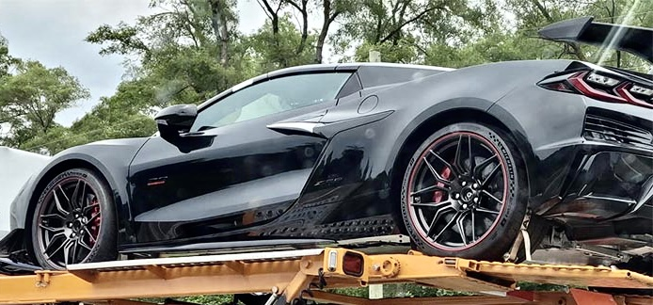
Simulated picture of Rick Hendrick’s VIN #001 car delivery:

Ever since GM’s President Mark Reuss noted on CNBC literally two days before last April’s Bash that both a hybrid and eventually an all-electric Corvette was coming, speculation has been over the moon. Such questions as: What will be its price range? What will its power level be, e.g., faster to 60 MPH than a Z06? Will it have one electric motor up front or two? Will it consequently lose any or all of its frunk space? There is one other question but that one have been answered with this picture, e.g., that it will be the first AWD Corvette (as shown in the circular, front, half shaft, within the front knuckle, block-out picture below). There are 10 major questions about the E-Ray of which less than two are completely answered but for more information and discussion: https://www.midenginecorvetteforum.com/forum/mid-engine-corvettes/c8-e-ray-powertrain/413699-fwiw-e-ray-predictions

How good is the Z06’s performance? By the time most of you are reading this, October 3rd will have occurred. What is important to that date? It is when the top, third-party, automedia press’ driving/testing of the Z06’s that were given to each one of them to individually test will have ended. We will be able for the first time to get non-GM evaluations of the car, both on public streets and on a race track. Questions such as can this race track C8 version truly be competitive on the track; how it is like to drive it on the public streets; how fast is it really; what are its strengths;, and many more performance measured and also top auto analyst impressions will initially answered. I think it safe to say every prospective Z06 owner is looking forward to watching those videos and to read those independent analyses of the Z06. We will be covering every one at the MidEngineCorvetteForum.

Meanwhile and way most importantly, as the weather changes toward winter in two-thirds of our country, may you get in your fall Corvette drives! Be safe as you experience more miles of Corvettes driving smiles!

